Cost and Benefit Analysis
The Cost-Benefit Analysis was performed in order to assess the cost-effectiveness of implementing the SCHOOLCARE+: Web-Based School Clinic Records and Inventory Management System against the current system that uses manual methods. The latter is based on paperwork and utilization of Microsoft Excel and Google Sheets for recording consultations, maintaining the inventory of medicines, and creating reports. Even though the manual approach demands little software expenditure, it consumes much time and increases the risk of human errors and complicates accessing the stored information.
On the other hand, the new system involves software expenditures at the initial stages when it is developed, tested, deployed, and implemented. Yet, these expenditures can be regarded as one-off expenses since maintenance, cloud hosting, and updates are needed after deployment only. In addition, it helps to reduce paperwork, minimize duplicates, facilitates reporting, and ensures the secure storage of students' health records.
In addition to savings in financial costs, SCHOOLCARE+ provides advantages on other fronts. Clinic staff will have instant access to patient’s medical history, track their medicine inventory in real time, receive automatic reports, and decrease administrative tasks. The system will increase data precision, prevent data losses, improve inventory management, and secure data by user authentication and authorization.

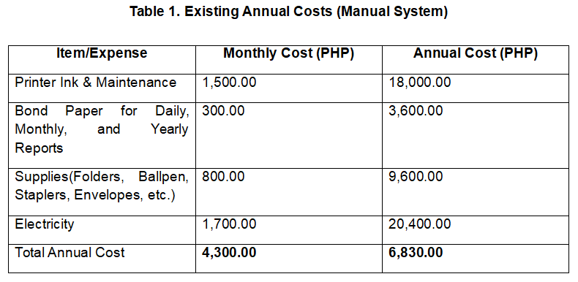
The financial analysis includes three tables. Table 1 includes an operating cost per year of existing manual system. Table 2 shows the one-time development cost of the proposed system. Table 3 includes the operating cost per year after the implementation of the system. This information serves as a base for the financial viability of the project.
Table 1 demonstrates the cost estimates of the current manual system of the clinic management. The total monthly cost is approximately ₱4,300.00 and yearly costs reach ₱51,600.00. This amount includes the cost of ink and maintenance for the printer, bond papers for printing the consultation records and reports, office supplies like folders, ballpens, staplers, and envelopes, as well as the electricity consumed in running the computers and printers. Even though the cost is quite low, there is an excessive use of papers in the manual system which leads to a poor record retrieving system because of the possibility of losing, misplacing the records, as well as creating duplicates and human errors. With the increase of students in the school, the number of records will only become greater and will be harder to manage in the manual way.
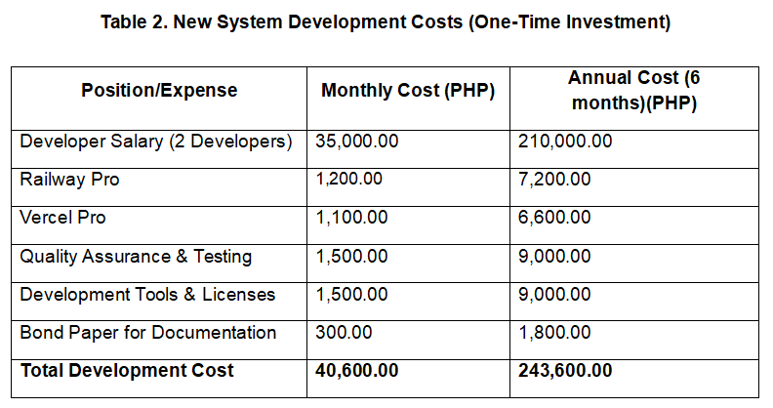
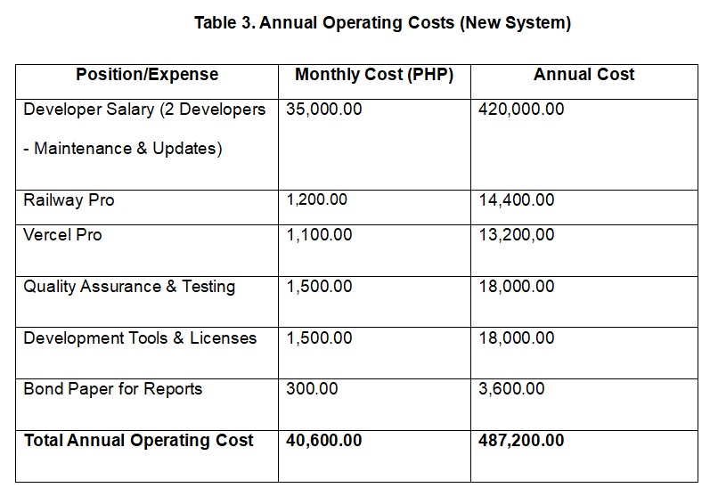
Table 2 provides the calculated development cost of designing, developing, testing, and implementing the SCHOOLCARE+ Web-Based School Clinic Records and Inventory Management System. The total development cost is ₱243,600.00, with an estimated monthly cost of ₱40,600.00 per month within six months of development. The majority of the budget goes into the salary of the developers, as this covers the effort and skill needed to conduct the system analysis, interface design, programming, database development, testing, and implementation of the system. Other costs include subscriptions for Railway Pro and Vercel Pro for cloud hosting, quality assurance and testing, software and tools for development, and documentation. As the cost will only be incurred during the development process, this cost is classified as one-time only. The one-time cost is important in making sure that the system is reliable and secure to use, and can help make the operation of school clinics more efficient with digital health records and inventory management system.
The estimated annual cost of operation of the SCHOOLCARE+ Web-Based School Clinic Records and Inventory Management System will be provided in Table 3 after the implementation of the system. The system has an estimated monthly cost of operation of ₱10,600.00 which translates to an annual cost of operation of ₱127,200.00. The above cost will be incurred for system maintenance and updates, cloud computing services using Railway Pro and Vercel Pro, quality assurance processes, development tools and software licenses, and a minimal amount of bond paper for printing of reports only. Unlike the existing manual system, clinic records and reports will be digitalized in the proposed system, meaning that the amount of papers used for recording of clinic activities will be minimal. Although the cost of operation of the system is higher compared to the cost of operations of the existing manual system, the incurred costs ensure that the system operates efficiently and securely throughout.

